Name:_______________________________________ Date:___________ Block:________ Teacher:______________
Research Mini-Assignment
Directions:
Please research one of the food items below and write a short report (no longer than 2 paragraphs) answering the following questions:
- Describe your food item. (English)
- What is your food item’s scientific name? What kind of food is it (fruit, vegetable, other)? (Science)
- Where is your food item grown or produced? (Geography)
- How much does your food item cost to produce and consume? (Math)
- What are the health benefits of your food item? (Physical Education)
- Provide 1 picture of your food item. (Art)
- Based on this evidence, make conclusions about if you would encourage or discourage people from buying and eating your food item. Why or why not? (Critical Thinking)
Food items (if you would like to choose another food item please ask)
Apple Pear Strawberry Banana Soy Wheat Bean
Broccoli Spinach Carrot Onion Potato Salt
Chocolate Coffee Cheese Garlic Rice Peppercorn
Your paragraph should be accompanied by the following things:
- MLA style In-text citations
- 4 or more academic sources (remember you must cite everywhere you found information—including pictures, videos, graphs, etc.)
- A MLA style bibliography
- A list of where you searched (EBSCO, Newsbank, Google, library book etc.) and what search terms you used.

This assignment should be typed in a Word Document and sent to Ms. Goetz via email (mgoetz@isp.edu.pa) It is due by ________________________.

Research Notes
A reliable source is: One that you can trust—academic, peer-reviewed, cites their own reliable sources, gives information about the author.
Examples include: journal articles, encyclopedia, .edu websites
A non-reliable source is: one that you cannot trust! Anonymous people have access to add content or change things, no sources are cited or poor sources are.
Examples include: WIKIPEDIA, blogs, answer websites
Databases the library has access to: EBSCO, Newsbank, Ebrary
How do I get to them…at school?
Links on the Library computers
…at home?
ISP or www.Yourlibrary.yolasite.com website. Use the links, and the username: ISP, the password: library
A primary source is: a source taken directly from the time, place, event or person you are researching.
Examples include: pictures, autobiographies, interviews, documents (letters, checks, contracts)
A secondary source is: a source that is 2nd hand knowledge—someone is talking or examining the primary information
Examples include: newspaper articles, research papers
MLA style is: a paper and citation formatting style put out by the Modern Language Association
I can find help and examples at: OWL at Purdue, Bibme, EasyBib, CitationMachine
In-text citation is: telling where you got your information within the text of the paper/presentation. MLA format for in-text citation is (Author Last Name, pg#)
I can find help and examples at: OWL at Purdue
A Bibliography is: a list of all the sources you consulted, quoted, or took any information from. A Works Cited is only a list of sources that you quoted or paraphrased information from.
I can find help and examples at: OWL at Purdue
Why is it important to have good sources?

Why is it important to cite sources?

Mallory Goetz
February 27, 2012 EXAMPLE
Ms. Goetz
Library Research Seminar
Research Mini-Assignment
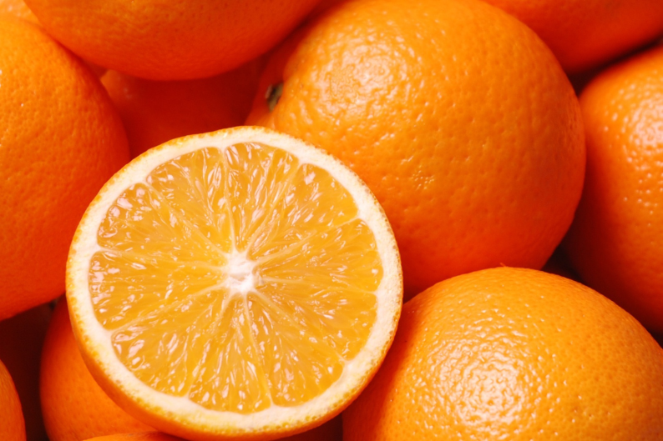
Figure 1: Photograph of oranges and a halved orange (sunnyUK).
The orange is a fruit characterized by its orange color, round shape, “rich citric acid and vitamin content,” and its many varieties (Orange, in Botany). The orange is the fruit from the orange tree which belongs to the Rutaceae tree family (Orange, in Botany). The most important types of orange fruits for commerce are the “sweet, or common, orange (C. sinensis) . . . the sour, or Seville, orange (C. aurantium) . . . [and] the mandarin (C. reticulata or nobilis)” (Orange, in Botany). The orange originated in China and IndoChina, ended up in the West Indies, Florida, and California due to trade and global exploration, but “the orange now grows in the warm parts of all continents” and is shipped all over the world as a fruit product for consumption (Orange, in Botany). This consumption creates a large orange production need. A study done by the University of California Cooperative Extension, found that costs for the production of oranges in the San Joaquin Valley of California are approximately $3,966 for the first year of starting an orchard (see Table 1) and profits do not start accumulating until the 4th and 5th years of a working orchard (O’Connell et al. 14-15).
Production Year: 1 2 3 4 5

Table 1: Estimated costs and profits of running an orange orchard (per acre) in the San Joaquin Valley, California, USA for the first 5 years (O'Connell et al. 14-15)

For the consumer oranges are one of the cheaper fruits to buy. In a study by the United States Department of Agriculture (USDA), oranges only cost an average of $0.74 per pound for the consumer (see Figure 2) and, as such, is much cheaper than a large variety of other fruits (Reed, 11-23).
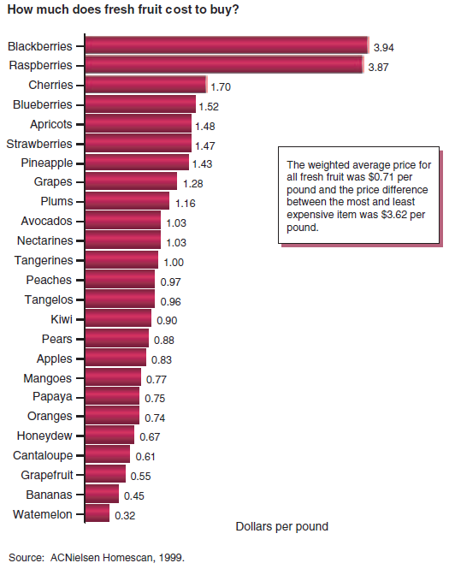
Figure 2: Price of fresh fruit in the US per pound (Reed, 11).

Oranges also may be so widely consumed because of their health benefits. “Healthy adults should eat between 20 to 35 grams of dietary fiber each day” and oranges contain soluble fiber; which could lower risk of heart disease if combined with a low-fat diet (Baggarly). Oranges also contain flavonol hesperidin which, in a French study reported in Nursing Standard Journal, lowered the risk of cardiovascular disease (Flavonol In Orange Juice Contributes To A Healthy Heart, 16-17). In addition, it seems that everyone knows oranges are high in vitamin C, citric acid, and other vitamins. In fact, “just one large orange provides 163% DV (Percent Daily Value, based on 2,000 calories per day). Vitamin C is important for many body functions, including maintaining bones, teeth, muscles, skin, ligaments and blood vessels; acting as an antioxidant to fight damaging free radicals that can lead to disease, healing wounds, and promoting a healthy immune function” (Zesty Citrus Fruits Signal Powerful Health Benefits, 3). Oranges are rich in:

…potassium, folate, calcium, thiamin, niaein, vitamin B6, phosphorus, magnesium, copper, riboflavin, and pantothenic acid,. . . fibers like pectin and lignin, which are linked with heart protection. In addition, more than 170 different phytochemicals have been identified in citrus fruits, including monoterpenes, limonoids. flavonoids, and carotenoids, which have documented antioxidant, anti-inflammatory, immune-boosting, and anti-cancer effects.

Eating citrus has been linked with protection from heart disease, stroke, arthritis, asthma,
Alzheimer's disease, cognitive decline, multiple sclerosis, age-related eye disease, ulcerative colitis, and diabetes, according to a review of the science on citrus fruits and health performed by Australia's research organization. The Commonwealth Scientific and Industrial Research. High citrus fruit intake also is linked with a 40 to 50 percent reduction in the risk of several cancers, such as esophageal, larynx, mouth, and stomach” (Zesty Citrus Fruits Signal Powerful Health Benefits, 3).
Oranges have such astounding health benefits, are available in different forms all over the world, and are considerable cheaper to the consumer than other fruits. As such, all people should eat oranges as often as possible, as a part of a healthy diet and a happy lifestyle.

Bibliography
Baggarly, Jan. "Filling up on fiber." Macon Telegraph, The (GA) 27 Feb. 2012,: NewsBank. Web. 28 Feb. 2012.
"Flavonol In Orange Juice Contributes To A Healthy Heart." Nursing Standard 25.26 (2011): 16-17. Advanced
Placement Source. Web. 28 Feb. 2012.
O'Connell, Neil V., Craig E. Kallsen, Karen M. Klonsky, and Richard L. De Moura. "Sample Costs to Establish
and Orange Orchard and Produce Oranges." UC Davis Cost Studies. University of California
Cooperative Extension, n.d. Web. 28 Feb. 2012. <coststudies.ucdavis.edu/files/orangevs2009.pdf>.
"Orange, In Botany." Columbia Electronic Encyclopedia, 6Th Edition (2011): 1. Literary Reference Center.
Web. 28 Feb. 2012.
Reed, Jane, Elizabeth Frazão, and Rachel Itskowitz. "How Much Do Americans Pay for Fruits and
Vegetables?." Economic Research Service. United States Department of Agriculture, n.d. Web. 28 Feb.
2012. <http://www.ers.usda.gov/publications/aib790/aib790.pdf>.
sunnyUK. 1506 Orange. 2008. Fotopedia, Online. Fotopedia. Web. 28 Feb. 2012.
"UC Studies Tree Fruit Production Costs." Western Farm Press 28.10 (2006): 32-33. Advanced Placement
Source. Web. 28 Feb. 2012.
"Zesty Citrus Fruits Signal Powerful Health Benefits." Environmental Nutrition 35.2 (2012): 3. Advanced
Placement Source. Web. 28 Feb. 2012.
Search List
Where I searched | Search Terms | Find Anything?
EBSCO | orange | yes
 | Orange and health benefits | Yes
 | Orange and production costs | No
 | Orange and fruit and production costs | yes
Newsbank | Orange and health benefits | No
 | Orange and fruit and health benefits | yes
Google Image Search | Labeled for reuse: orange | Yes
Google Web Browser | Average orange cost | No
 | Average orange fruit cost | yes

